Project Design Phase-I Solution Architecture

|  |  |
| --- | --- |
| Date | 26 October 2022 |
| Team ID | PNT2022TMID31571 |
| Project Name | Smart Fashion Recommender Application |
| Maximum Marks | 4 Marks |

Solution Architecture:

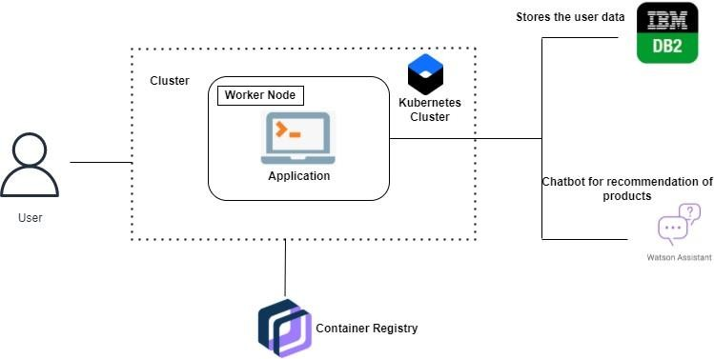

USER Admin

*l*



recommender

systems

DataBase



Chat Bot

DartaBase

StockManitanace

Dress Collections

USER